Docker Task -2

Step 1:
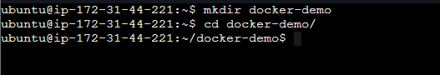

Step 2:
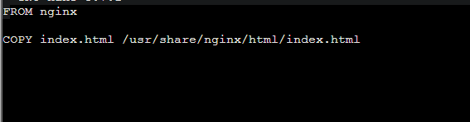

Step 3:
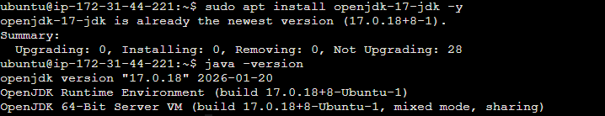

Step 4:
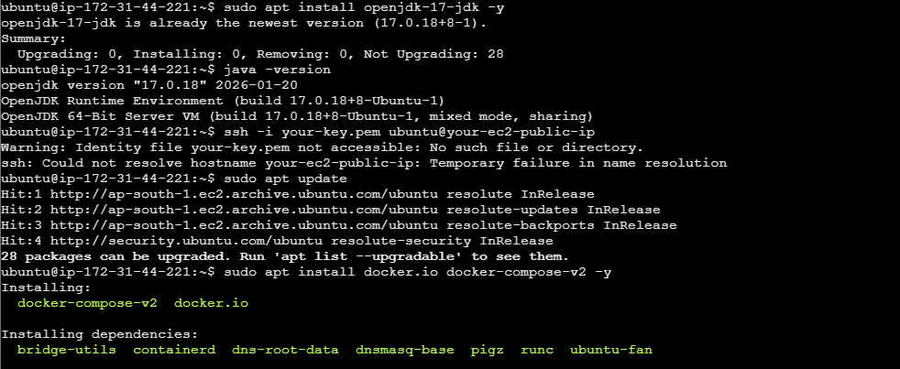

Step 5:
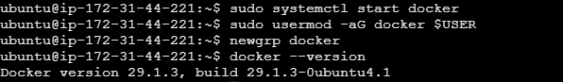

Step 6:

Step 7:
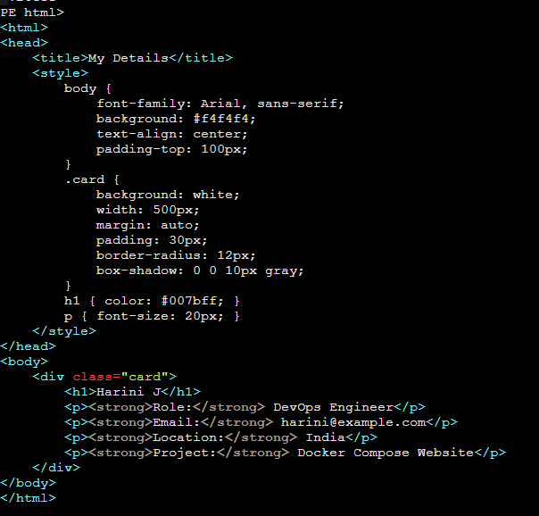

Step 8:
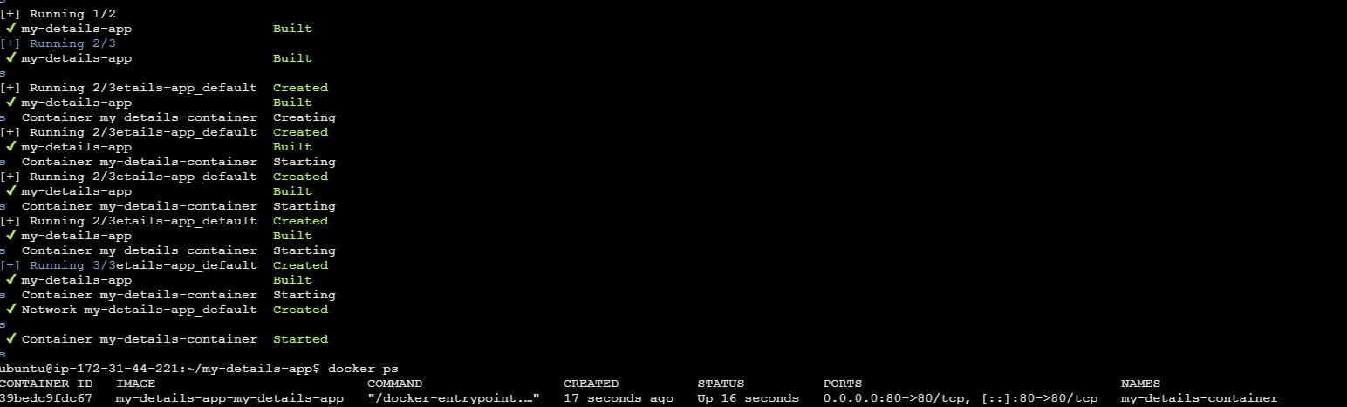

Step 9:
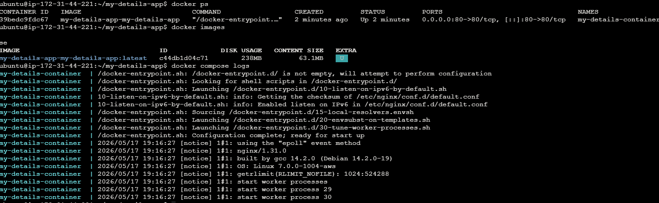

Step 10:
